SIMATS ENGINEERING
ASSESSMENT TOOL 2

COURSE NAME: Ethical Hacking COURSE CODE: ITA14

COURSE OUTCOME COVERED

CO2: Foot printing Tools: Conducting Competitive Intelligence, DNS Zone Transfers, Introduction to Social Engineering: Social Engineering Attacks and Countermeasures. (BT4)

Assessment Tool Weightage: 30%

Duration: 90 min Total Marks: 50

Social Engineering Simulation

Questions

- As a Security Analyst, perform an OSINT-based email enumeration assessment on the target domain tesla.com using theHarvester in Kali Linux. Collect publicly available email addresses, subdomains, hosts, and IP addresses associated with the organization. Categorize the discovered email addresses into likely roles such as Support, Sales, Human Resources, Administration, and Technical Teams. Analyze how the gathered information could assist an attacker during the reconnaissance phase and explain how it could be used for spear-phishing, credential harvesting, and impersonation attacks. Finally, recommend at least five countermeasures to reduce information leakage and social engineering risks, and submit a report with screenshots, commands executed, findings, risk analysis, and recommendations.

Sol : To perform an OSINT-based reconnaissance on tesla.com using theHarvester in Kali Linux and identify publicly available information such as subdomains, hosts, email addresses, and IP addresses.

Command 1 : theHarvester -d tesla.com -b rapiddns

Purpose :
This command performs an OSINT scan on the target domain tesla.com using the RapidDNS search engine. It collects publicly available information such as email addresses, subdomains, hosts, and IP addresses.

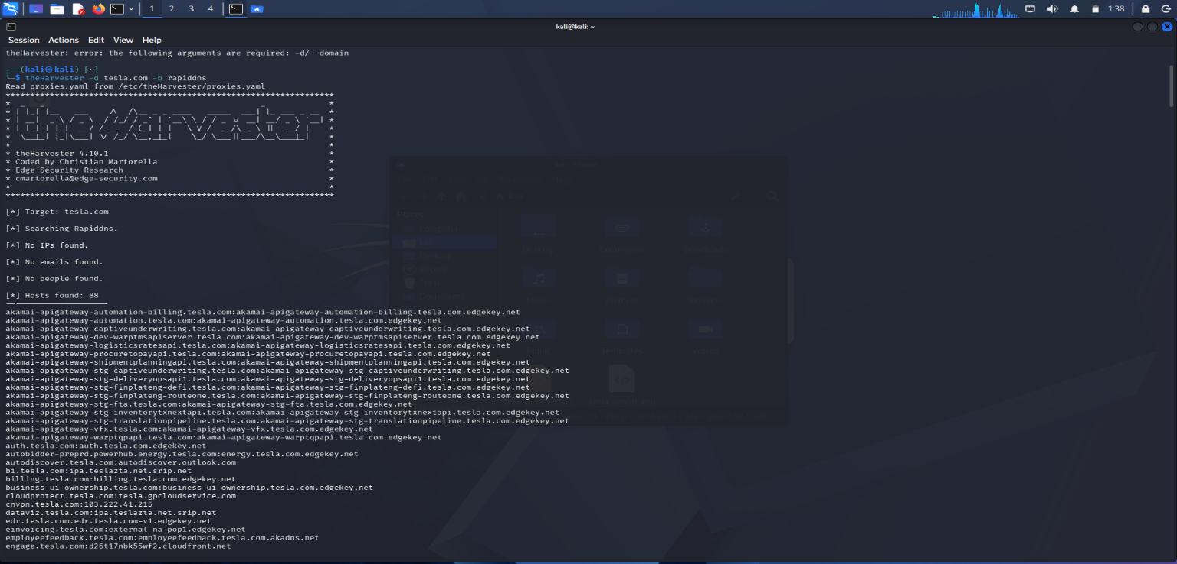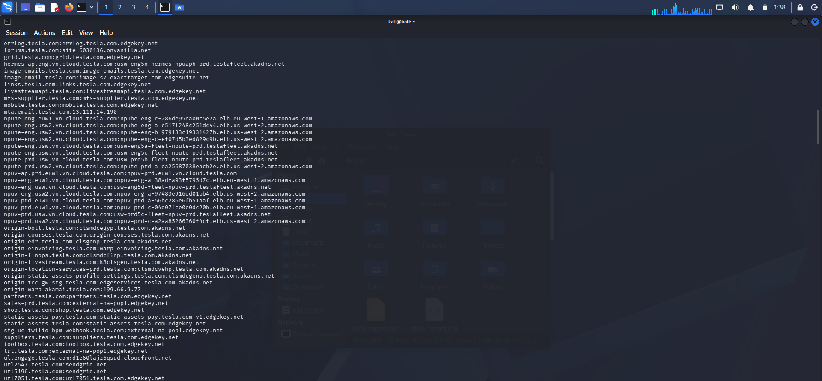

Command 2 : theHarvester -d tesla.com -b rapiddns -n

Purpose :
This command performs DNS lookup on the discovered hosts to retrieve DNS-related information and verify the discovered domains.

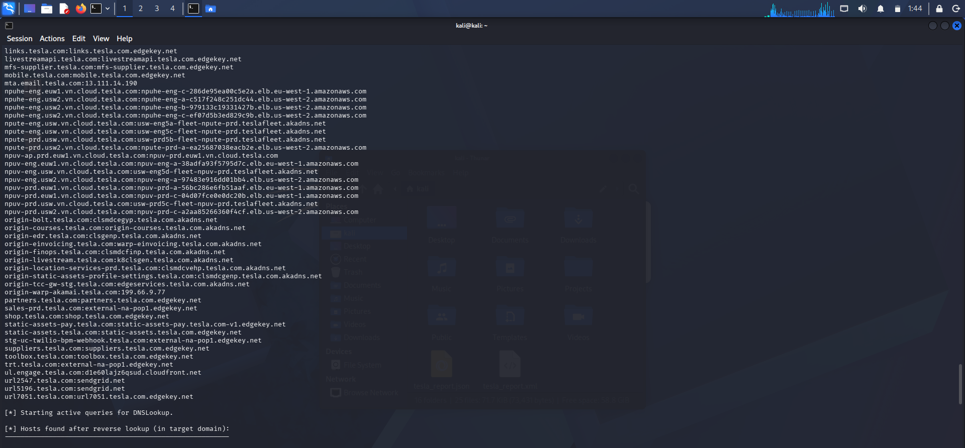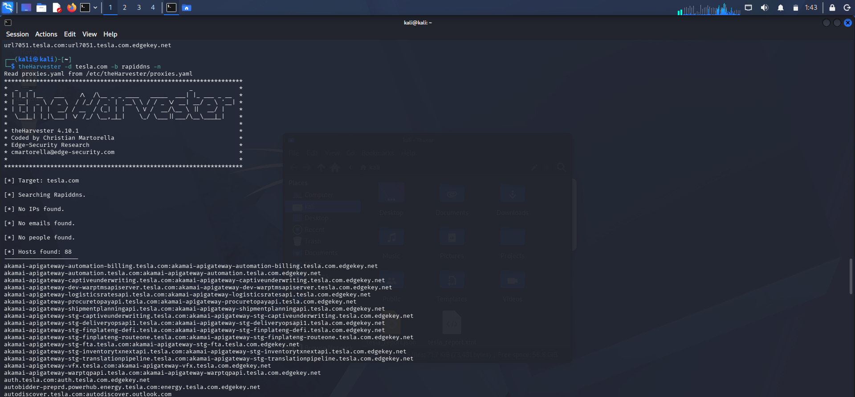

Findings
Target Domain: tesla.com
Information Collected
Item | Result
Email Addresses | No public email addresses found
IP Addresses | No public IP addresses found
Hosts/Subdomains | 88 Hosts Found
People | No people found

Risk Analysis
The discovered subdomains provide useful reconnaissance information about Tesla's public infrastructure. An attacker could use these hostnames to understand exposed services, identify potential targets, and prepare phishing or impersonation attacks. Although no public email addresses were found, the discovered hosts can still support reconnaissance when combined with other OSINT sources.

Countermeasures
- Conduct regular OSINT assessments to identify exposed information.
- Enable Multi-Factor Authentication (MFA).
- Train employees to recognize phishing attacks.
- Reduce unnecessary exposure of public subdomains.
- Continuously monitor public-facing assets and DNS records.
Conclusion :
The OSINT assessment successfully identified 88 public hosts/subdomains related to tesla.com. No public email addresses or IP addresses were discovered. The collected information demonstrates how attackers can gather infrastructure details during the reconnaissance phase and highlights the importance of minimizing public information exposure and implementing strong security controls.

- As a cybersecurity awareness consultant, you are required to conduct a phishing awareness simulation using GoPhish and dummy employee accounts provided in the lab. Create an email template, launch a campaign, monitor user interactions, and generate a report showing delivery rate, email open rate, and click rate. Based on the results, provide recommendations to improve user awareness against phishing attacks.
Sol : To conduct a phishing awareness simulation using GoPhish by creating an email template, sending phishing emails to dummy employee accounts, monitoring user interactions, and generating a report showing delivery rate, email open rate, and click rate. Finally, recommendations are provided to improve user awareness against phishing attacks.

Command 1 : sudo apt update

Purpose :
Updates the Kali Linux package repository to ensure the latest package information is available before installing software.

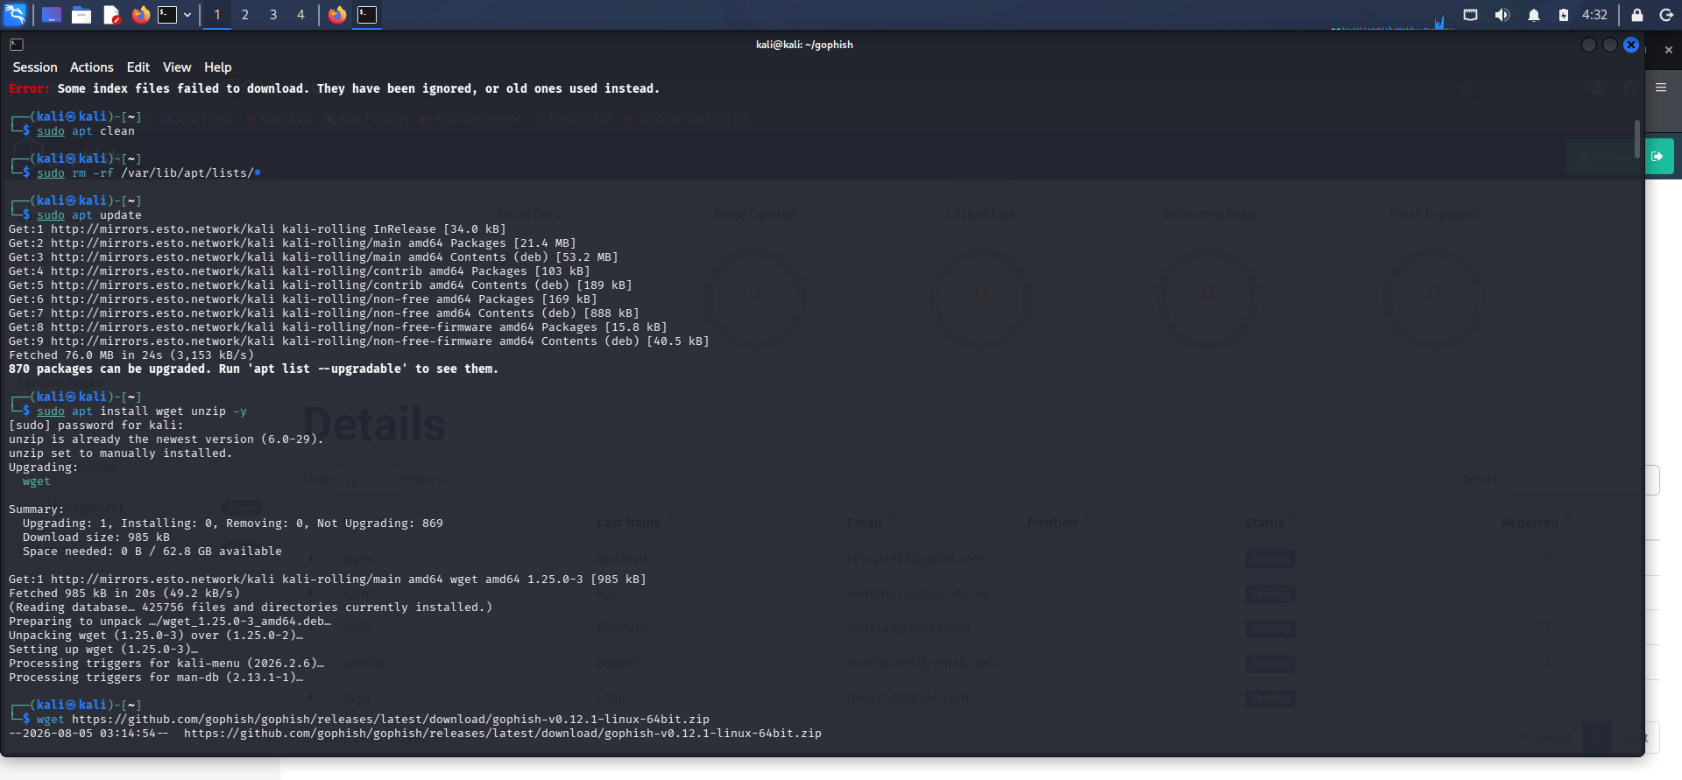
Command 2 : wget https://github.com/gophish/gophish/releases/latest/download/gophish-v0.12.1-linux-64bit.zip

Purpose :
Downloads the latest GoPhish Linux package from the official GitHub repository.

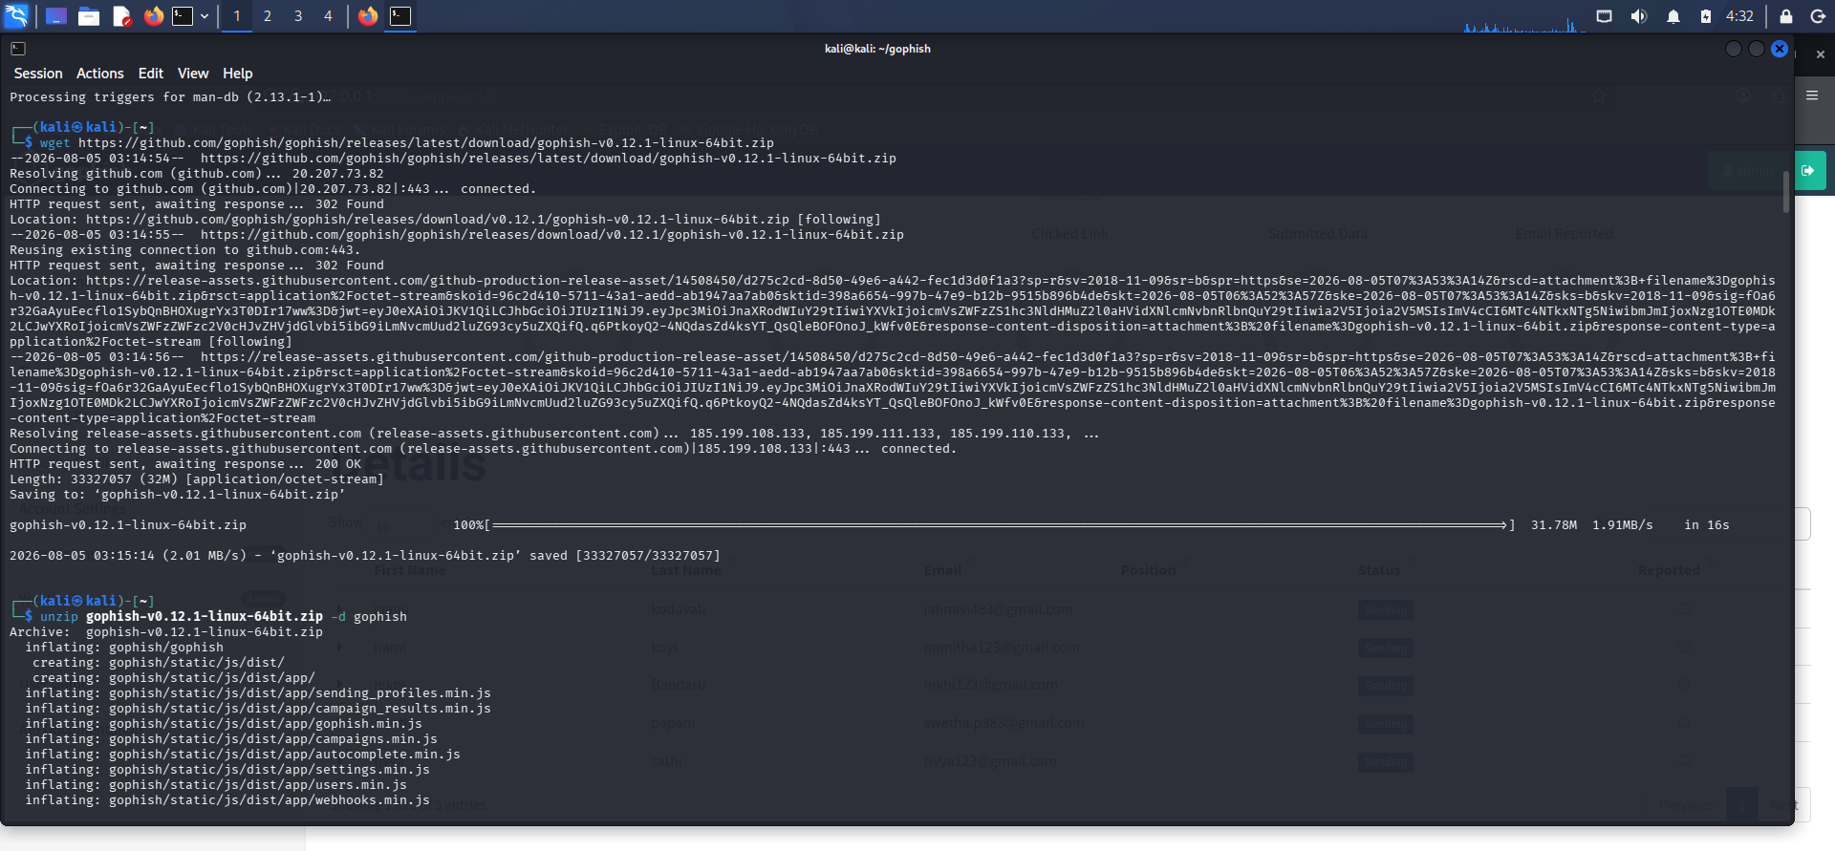
Command 3 : unzip gophish-v0.12.1-linux-64bit.zip -d gophish
Command 4 : cd gophish
Command 5 : chmod +x gophish
Command 5 : sudo ./gophish

Purpose :
Extracts the downloaded GoPhish ZIP archive into the gophish directory. Changes the current working directory to the GoPhish installation folder. Grants execute permission to the GoPhish executable so that it can be started. Starts the GoPhish application, initializes the database, generates SSL certificates if required, and launches the phishing server and the administration web interface.

Report : https://127.0.0.1:3333/

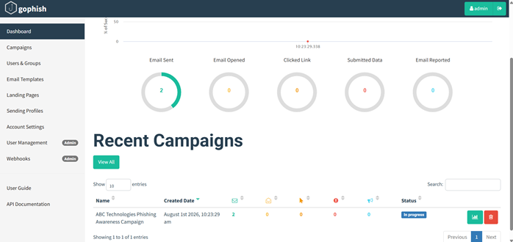

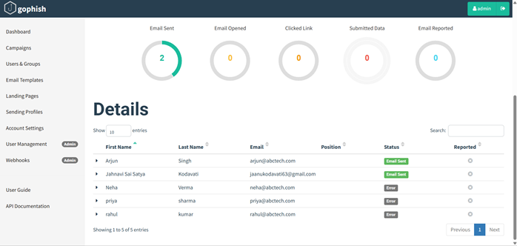

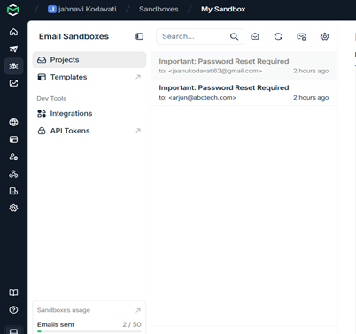

Email Security Controls :
- Enable Spam Filtering.
- Use Email Gateways.
- Configure SPF (Sender Policy Framework).
- Configure DKIM (DomainKeys Identified Mail).
- Configure DMARC (Domain-based Message Authentication, Reporting, and Conformance).
- Block dangerous attachments.
- Scan email attachments using antivirus software.
- Enable URL filtering.

- Using Nmap Aggressive Scan (-A) on scanme.nmap.org, gather detailed information about the target including operating system details, open ports, and service versions. Assume you are an attacker and describe how the collected information could be leveraged to conduct a social engineering attack against the IT support team. Prepare a report explaining the attack methodology and defensive recommendations.

Sol : To perform an aggressive scan on scanme.nmap.org using Nmap to identify the target operating system, open ports, running services, and service versions. The collected information is analyzed to understand how an attacker could use it in a social engineering attack against the IT support team and to recommend defensive measures.

Command 1 : nmap -A scanme.nmap.org

Purpose
Performs an Aggressive Scan on the target. The -A option enables:
- Operating System Detection
- Service Version Detection
- Script Scanning (NSE)
- Traceroute
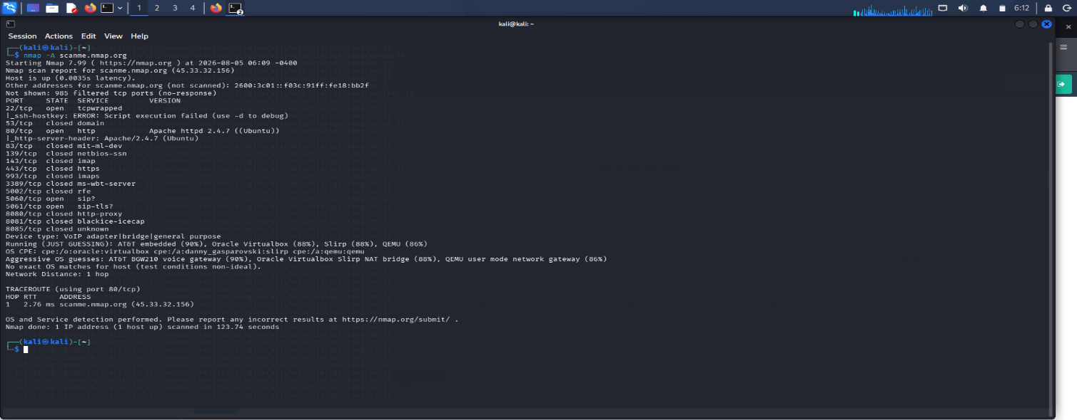

Findings :

Parameter | Result
Target Host | scanme.nmap.org
Target IP Address | 45.33.32.156
Host Status | Up
Network Distance | 1 Hop
Device Type | VoIP Adapter / Bridge / General Purpose

port | state | service | version
22 | Open | tcpwrapped | SSH Host
80 | Open | HTTP | Apache HTTP Server
5060 | Open | SIP | SIP Service
5061 | Open | SIP-TLS | Secure SIP Service

Attack Methodology

Step 1 - Reconnaissance
The attacker performs an Nmap Aggressive Scan to gather information about the target system, including operating system details, open ports, and running services.

Step 2 - Service Enumeration
The scan reveals:
- Apache HTTP Server 2.4.7 running on Ubuntu
- SSH service
- SIP and SIP-TLS services

Step 3 - Social Engineering Attack
The attacker contacts the IT support team pretending to be a network administrator or software vendor.

Step 4 - Credential Theft
If the IT support team trusts the attacker, they may reveal usernames, passwords, VPN details, or other sensitive information.

Risks
- Exposure of server information
- Credential theft
- Unauthorized system access

Conclusion
The Nmap Aggressive Scan successfully identified the target's IP address, open ports, running services, and probable operating system details. Such information can be valuable during the reconnaissance phase of an attack and may be used to conduct convincing social engineering attacks against IT support personnel. Implementing strong security controls, regular patch management, and employee awareness training can significantly reduce these risks.

Code of Conduct:

I P Reddy Swetha - 192311206 certify that this submission is my original work and that I have adhered to the guidelines specified for this assessment. I understand that any violation of academic integrity rules will result in disciplinary action.

Signature of the student: P Reddy Swetha

RUBRICS FOR CALCULATION

Social Engineering Simulation
Criteria | Weightage (%) | Level 4 (Exemplary) | Level 3 (Proficient) | Level 2 (Developing) | Level 1 (Beginning)
Understanding of Social Engineering Scenario | 20% | Demonstrates a comprehensive understanding of the social engineering scenario, attack techniques, and security context | Demonstrates good understanding with minor omissions. | Shows partial understanding but misses important aspects of the scenario. | Fails to understand or incorrectly interprets the social engineering scenario.
Identification of Attack and Vulnerabilities | 20% | Correctly identifies the attack type, exploited vulnerabilities, and affected assets with complete accuracy | Correctly identifies most attack techniques with minor errors. | Identifies only some attack methods and vulnerabilities. | Unable to identify the attack type or associated vulnerabilities.
Application of Security Concepts and Countermeasures | 25% | Effectively applies cybersecurity concepts and recommends appropriate preventive, detective, and corrective countermeasures. | Applies relevant concepts with minor errors and recommends suitable countermeasures. | Applies concepts partially with limited recommendations. | Unable to apply relevant cybersecurity concepts or recommend suitable countermeasures.
Risk Analysis and Decision Making | 20% | Performs logical risk analysis, evaluates business impact, and provides well-justified security decisions. | Provides reasonable analysis with adequate justification. | Performs limited analysis with weak justification. | Provides no meaningful analysis or justification.
Clarity, Documentation and Technical Presentation | 15% | Response is well-organized, technically accurate, professionally documented, and logically presented. | Response is clear with minor documentation or presentation issues. | Response lacks organization and contains technical inaccuracies. | Response is poorly organized, incomplete, and difficult to understand.

